**First Access File is loaded**

1. Check Null Fields
2. Check if it has proper data types
3. Check Foreign Key References

**Filter Rows**

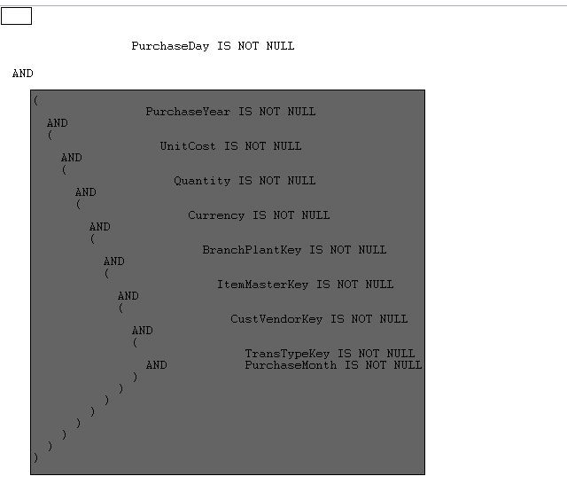

**DataValidator (Check Data Type)**

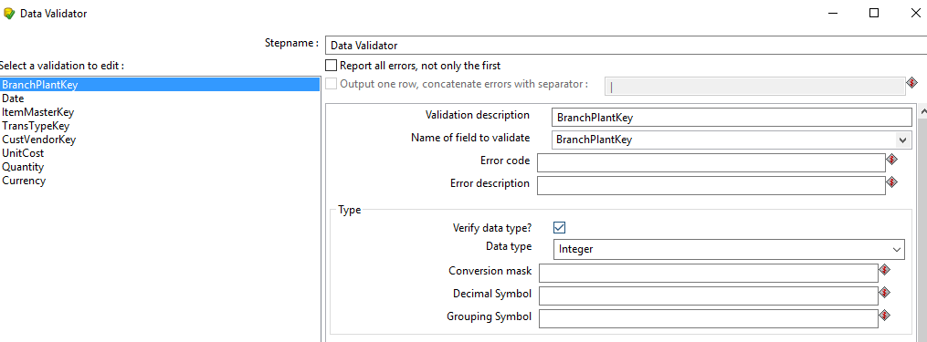

**Transformation:**

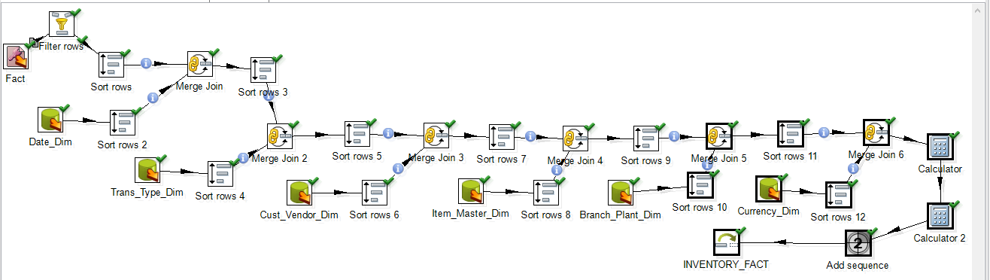

**After running the above, Transformation,11 rows were inserted.**

